

**Project Name:** BCD to 7 Segment display

**Candidates:**  Muhammad Subhan Attique ( P20-0049 )

Izaan Mohtashim ( P20-0613 )

Junaid Ali ( P20-0597 )

**Section:** BS-CS ©

**Submitted to:** Sir Shakir-Ullah

*Introduction:*

BCD to 7 segment display is a setup that converts binary numbers to decimal on the basis of inputs given by the user and simply displays that decimal number on 7 segment display.

*BCD:*

****BCD**** stands for ****binary coded decimal****. It is a digital numbering system in which we can represent each decimal number using 4 bits of binary numbers.

*Apparatus Required:*

- Trainer

- Breadboard

- ICs (AND,OR,NOT)

- Wires

- 7 segment display

*Explanation:*

‘[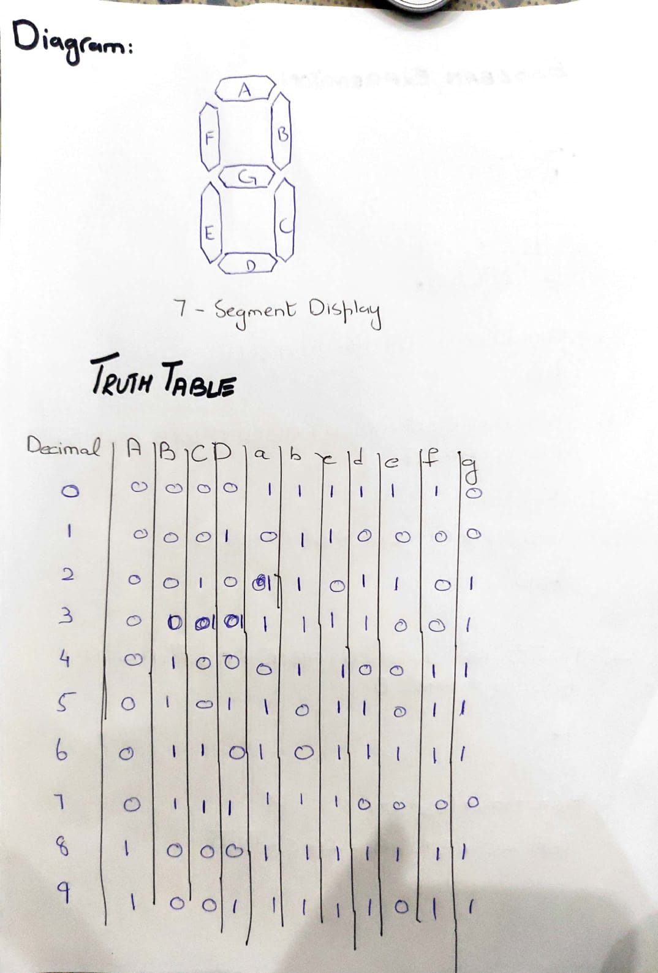

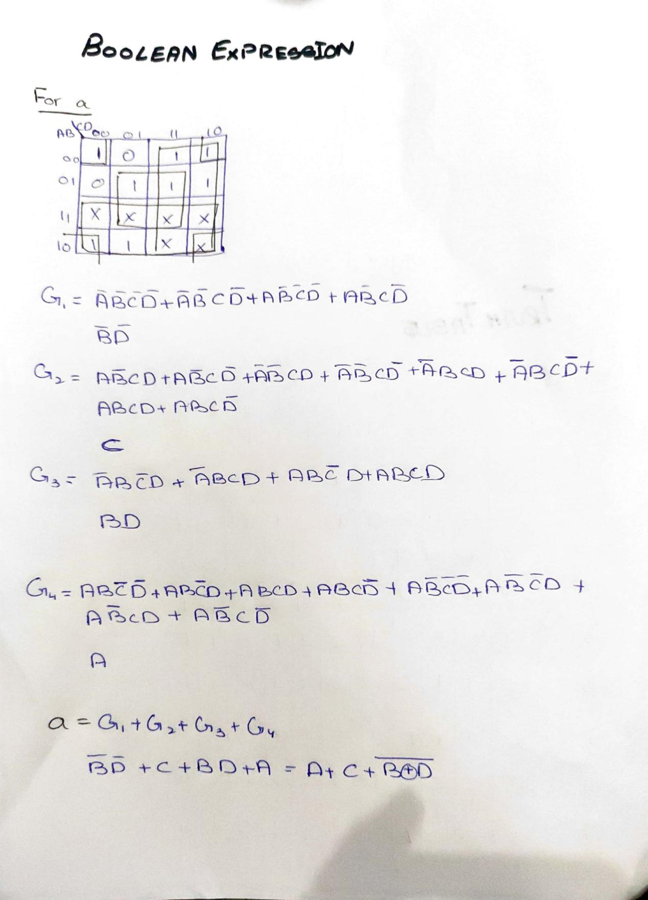

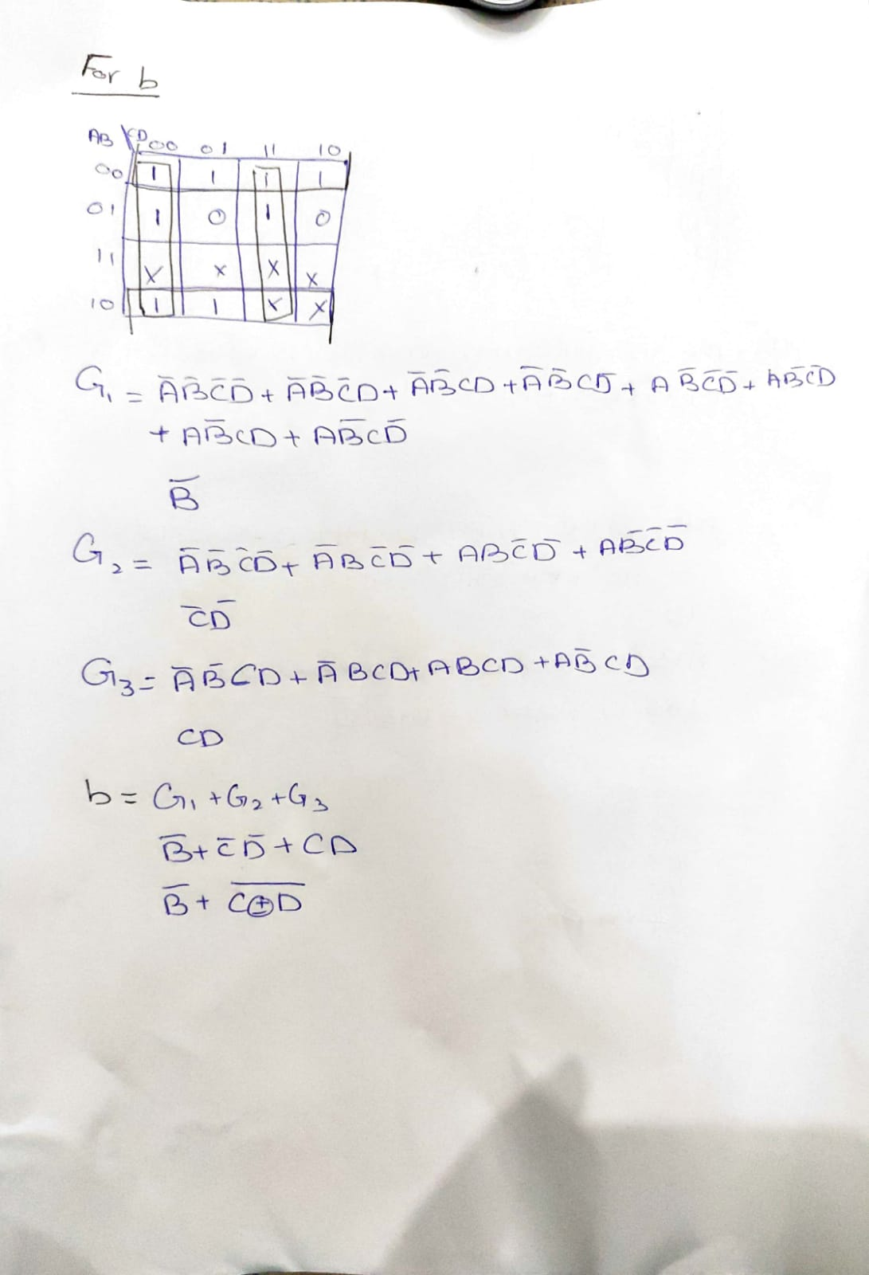

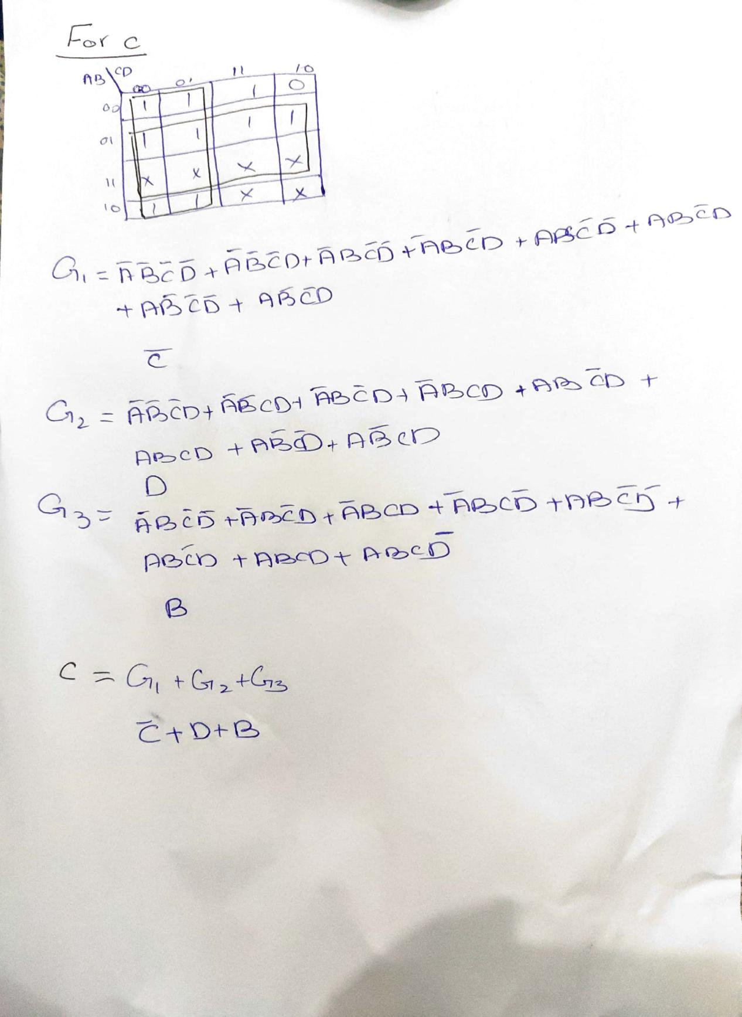

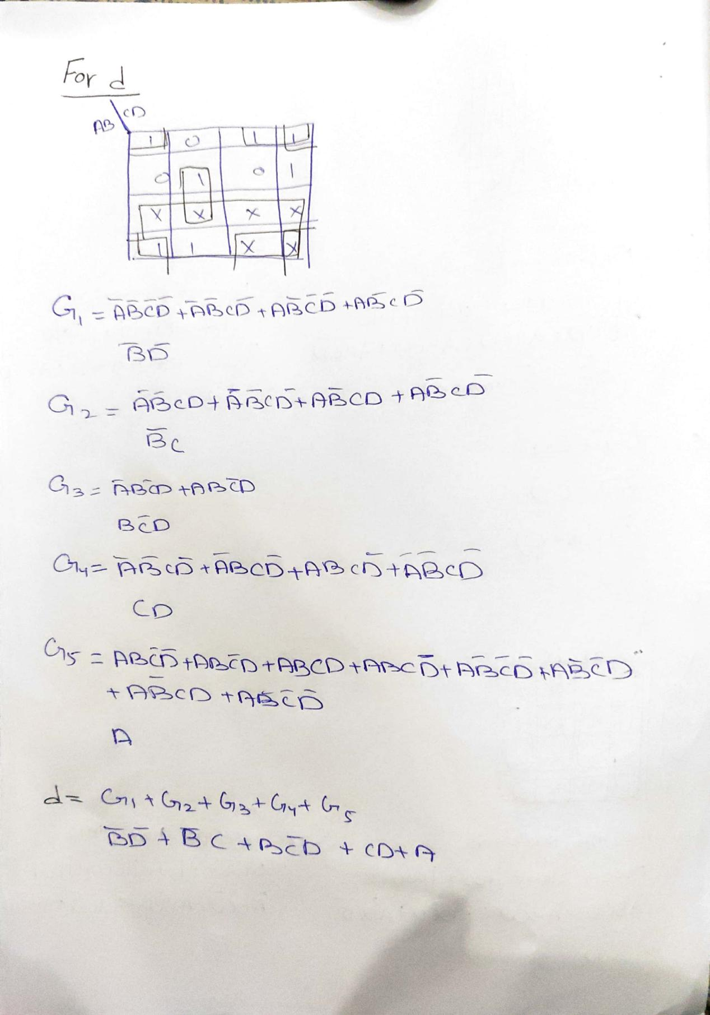

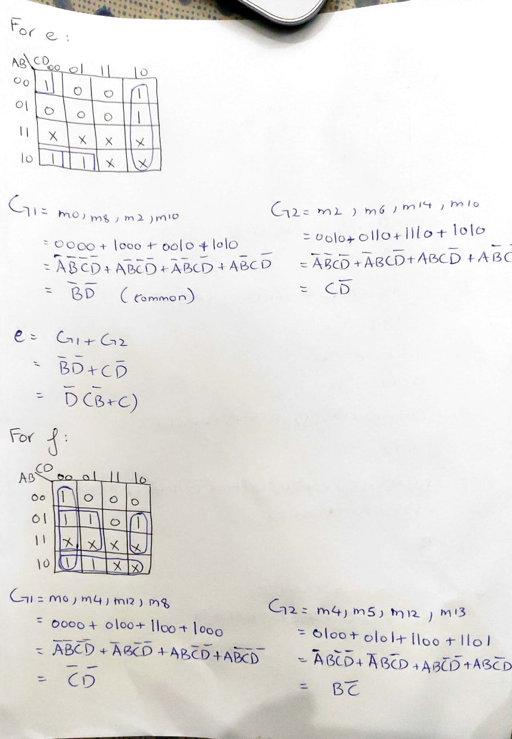

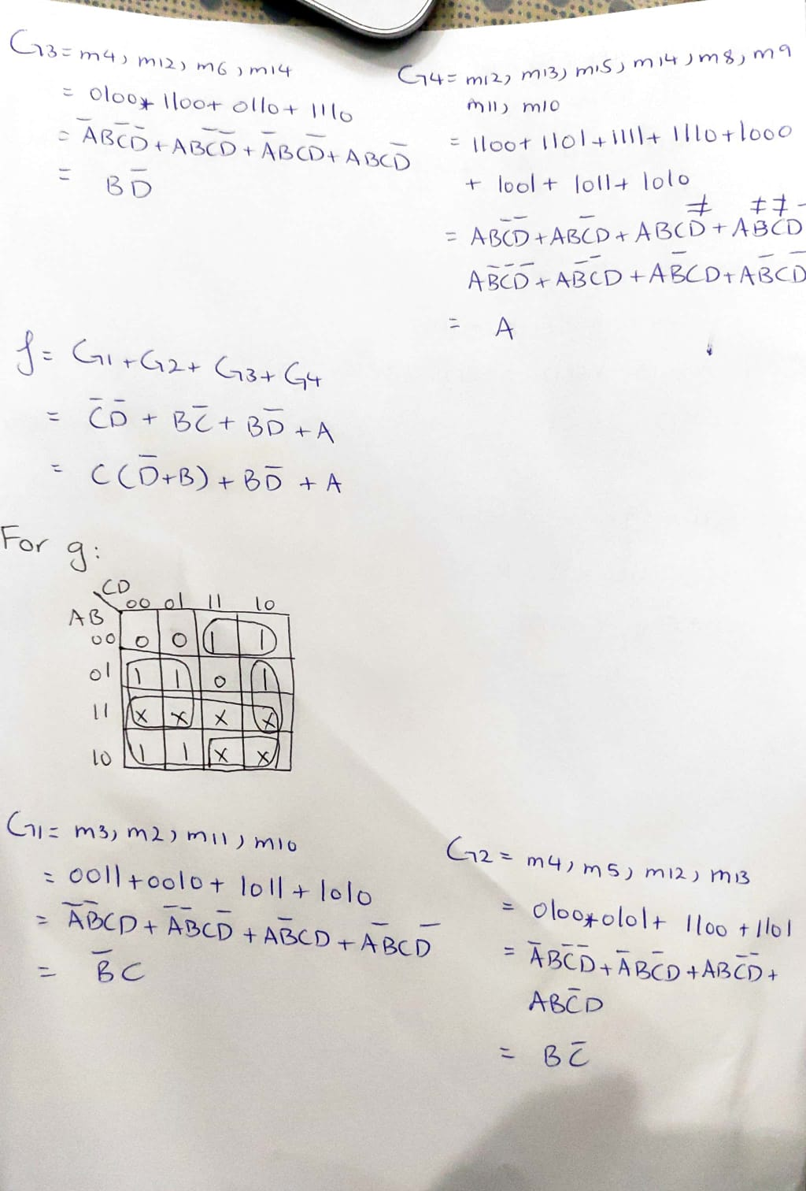

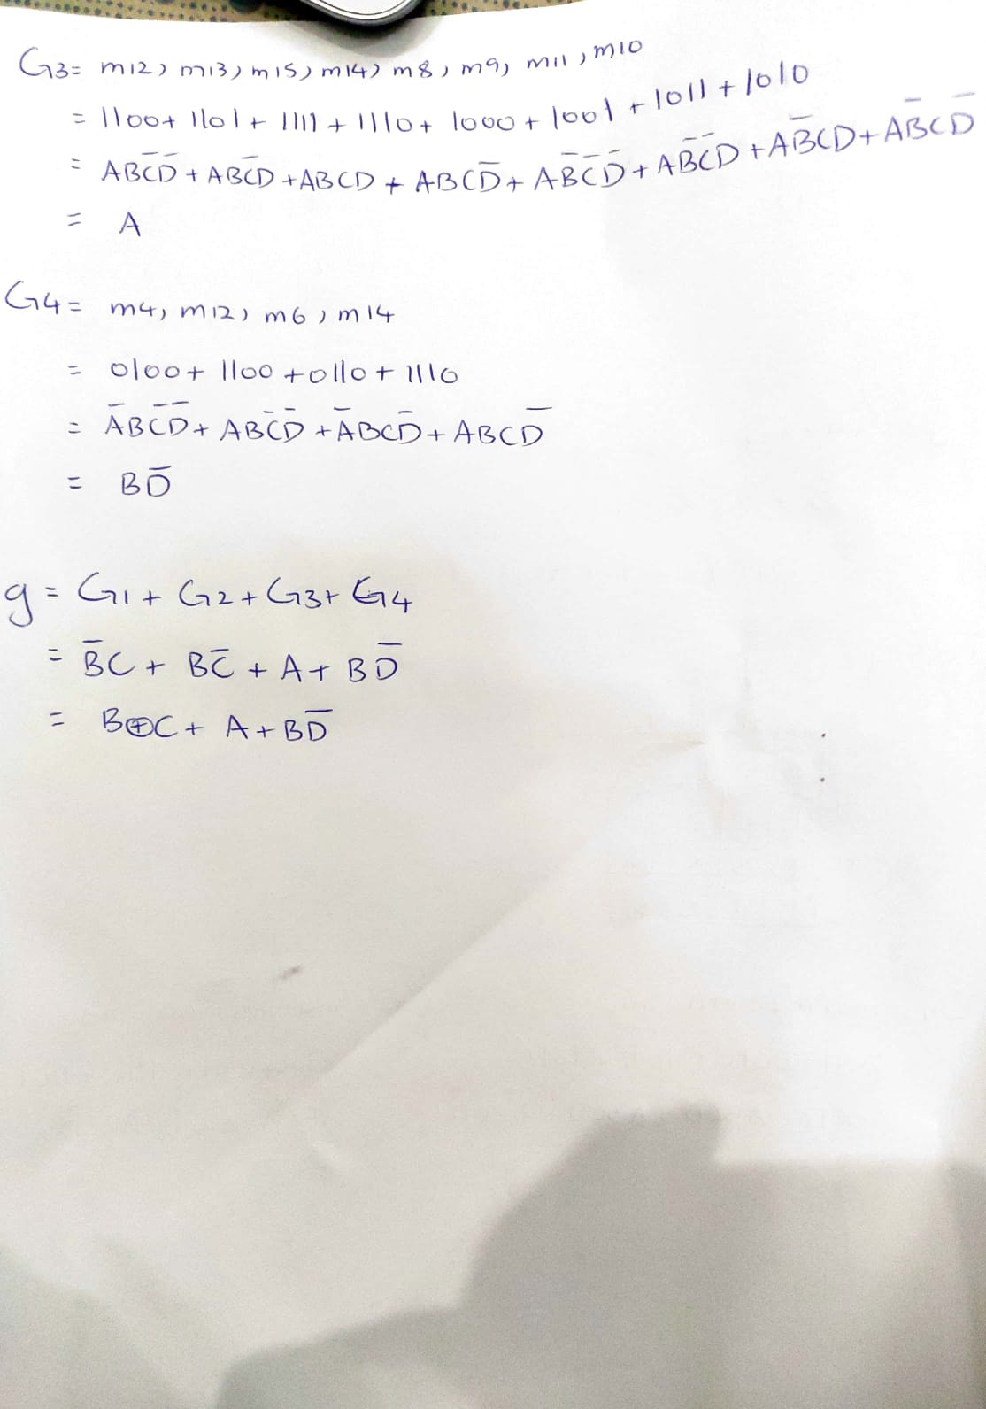

*Diagram:*

For 0:

We will turn on a,b,c,d,e,f in order to get 0.

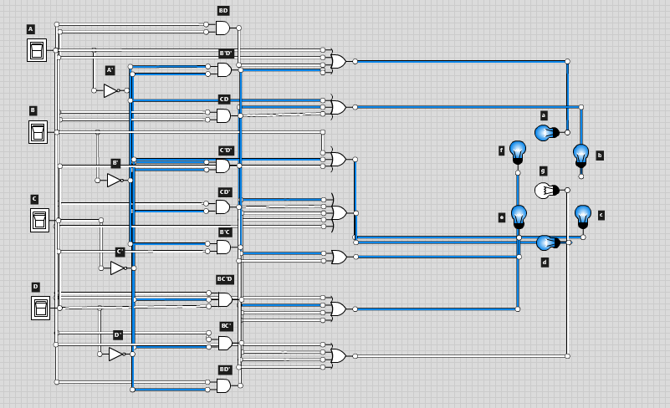

For 1:

We will turn on b,c for 1.

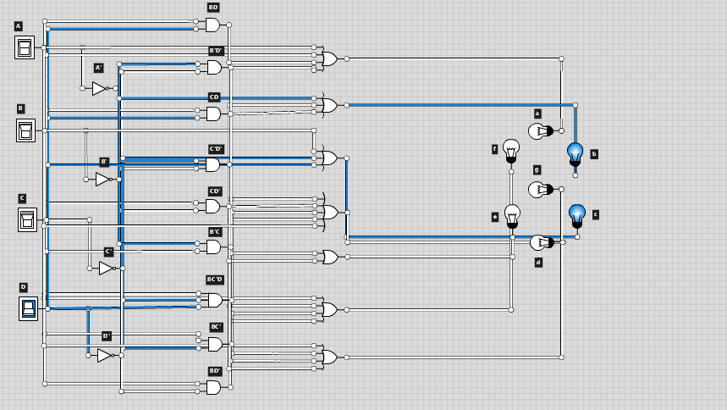

For 2:

We will turn on  a, b, d, e, g.for 2.

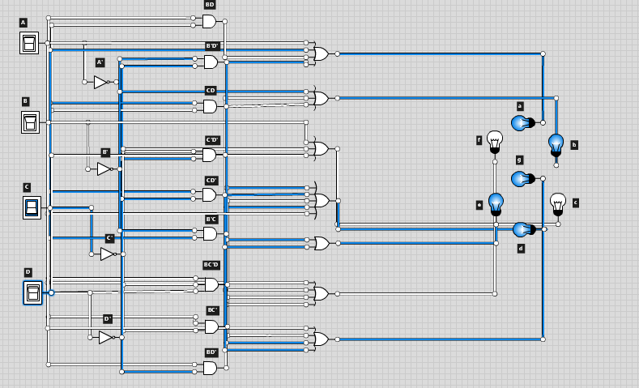

For 3:

We will turn on a, b, c, d, g.for 3.

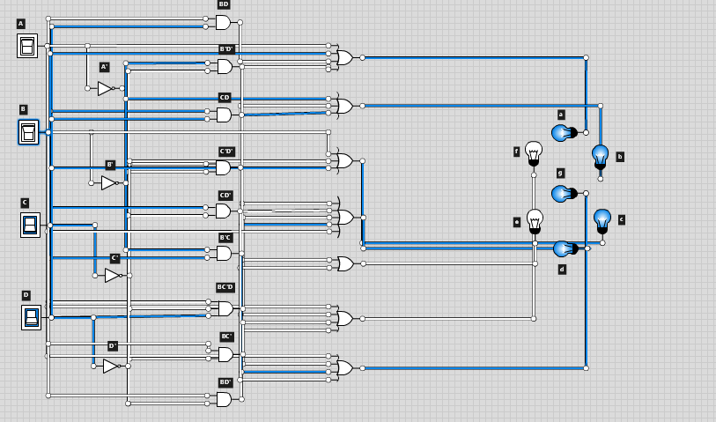

For 4:

We will turn on b, c, f, g.for 4.

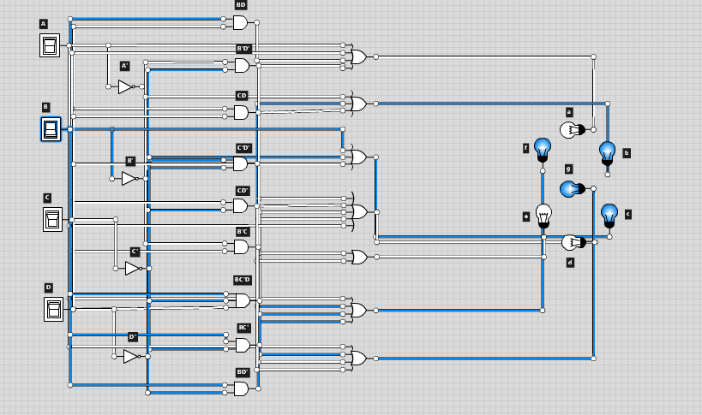

For 5:

We will turn on a, c, d, f, g.for 5.

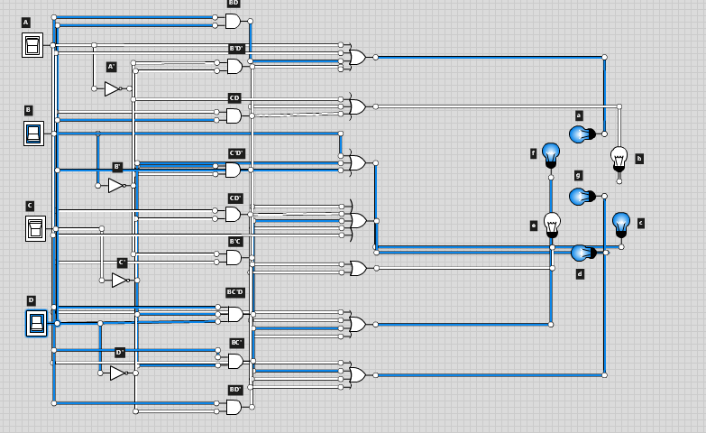

For 6:

We will turn on a, c, d, e, f, g for 6.

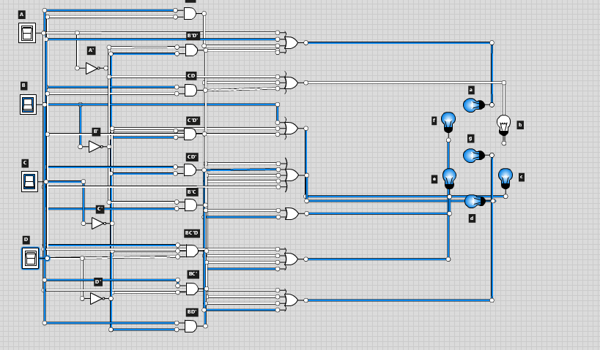

For 7:

We will turn on a, b, c for 7.

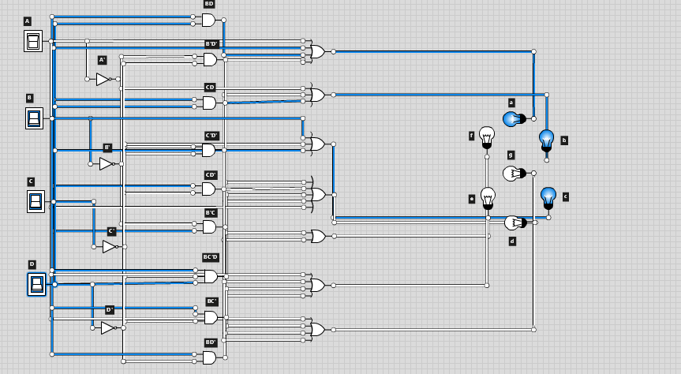

For 8:

We will turn on a, b, c, d, e, g for 8.

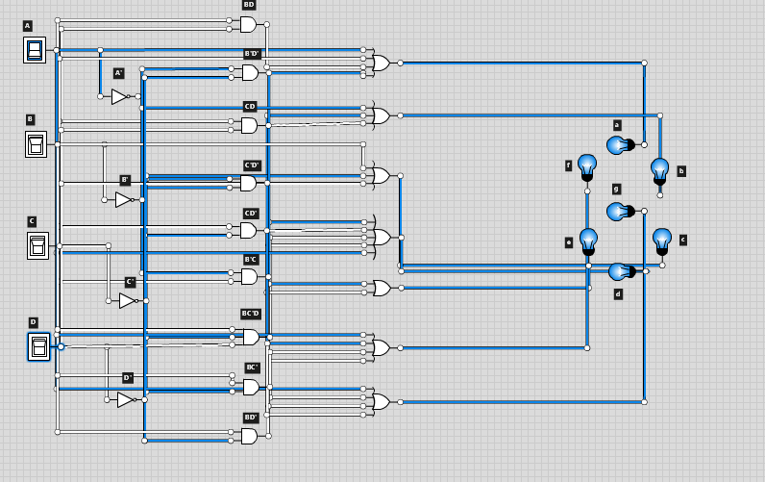

For 9:

We will turn on a, b, c, d, f, g for 9.

